***Mark the letter A, B, C or D on your answer sheet to indicate the word whose underlined part differs from the other three in pronunciation in each of the following questions.***

**1.** **A.** honest **B.** perhaps **C.** ahead **D.** happen

**2.** **A.** extended **B.** congested **C.** crooked **D.** occupied

***Mark the letter A, B, C or D on your answer sheet to indicate the word that differs from the other three in the position of primary stress in each of the following questions.***

**3.** **A.** allow **B.** urgent **C.** mental **D.** wander

**4.** **A.** community **B.** academic **C.** significant **D.** mysterious

***Mark the letter A, B, C or D on your answer sheet to indicate the correct answer to each of the following questions.***

**5.** If you visit a zoo and safari park, you can see wild animals in their ______.

**A.** concrete jungles **B.** natural habitats

**C.** package tours **D.** endangered species

**6.** The city council suggests ______ by public transport as a way to reduce air pollution.

**A.** travel **B.** to travel **C.** travelling **D.** to travelling

**7.** Nicky said that he _______ that vase at Bat Trang Pottery Village the previous day.

**A.** bought **B.** would buy **C.** has bought **D.** had bought

**8.** Alex’s family ______ snorkeling to see coral reefs in Phu Quoc as soon as it stops ______.

**A.** will go/ rain **B.** is going/ raining **C.** has gone/ rain **D.** will go/ raining

**9.** James wants to borrow a brochure from Chloe.

James: “Would you mind if I borrowed your brochure? ”

Chloe: “______”

**A.** Yes, please. That’s very kind of you.

**B.** Don’t worry. I can take you to the store.

**C.** Sorry, I already gave it to Linda.

**D.** That’s a good idea, tell me more about it.

**10.** Have you ever met the woman ______ married Linda’s cousin?

**A.** who **B.** whom **C.** which **D.** whose

**11.** Teens often follow celebrities on social media to ______ their latest news.

**A.** keep up with **B.** come down with **C.** come up with **D.** get on with

**12.** Keshi took ______ polaroids and videos when he attended The Eras Tour 2024 in Singapore.

**A.** less **B.** any **C.** much **D.** many

***Read the following announcement and mark the letter A, B, C or D on your answer sheet to indicate the correct option that best fits each of the numbered blanks from 13 to 16.***

| **HOW CAN YOU DEAL WITH STRESS?**   * Sports and exercises (13) ______ stress and also help you to sleep. * Talk to people about how you feel. * Listen to music. * Eat healthy, natural food, especially at breakfast-time (14) ______ that’s when you need the energy! * When the problem is homework or exams, it’s a good idea (15) ______ a plan or timetable. This helps you to find time to do everything, including time to do things that you love - surfing the Internet, chatting to friends, reading … * And be (16) ______! |
| --- |

**13.** **A.** delay **B.** combat **C.** support **D.** consist

**14. A.** because **B.** although **C.** therefore **D.** moreover

**15.** **A.** to do **B.** making **C.** doing **D.** to make

**16.** **A.** negative **B.** emotional **C.** positive **D.** thoughtful

***Mark the letter A, B, C or D on your answer sheet to indicate the correct answer to each of the following questions from 17 to 18.***

**17. Put the sentences (a-c) in the correct order, then fill in the blank to make a logical text.**

I realized that I was spending too much time on social media, so I made some changes to my daily routine. Firstly, I set time limits for my apps to control how much I use them. ______.

a. To avoid distractions, I also turned off notifications that I didn't need.

b. Secondly, I planned fun things to do offline, like reading or working out, so I wouldn't be bored.

c. Additionally, I prioritize spending quality time with friends and family, which strengthens our bonds and reduces phone use.

**A.** a - b - c **B.** b - c - a **C.** c - a - b **D.** c - b - a

**18. Choose the sentence that can end the text (in Question 17) most appropriately.**

**A.** However, sometimes I still find it difficult to resist the urge to check my phone.

**B.** Overall, these small changes have created a healthier balance and promote my mental health.

**C.** In conclusion, I hope my changes will inspire social media companies to create a safer platform.

**D.** So, I will explore more about how technology affects the younger generation.

***Mark the letter A, B, C or D on your answer sheet to indicate the correct option that best fits each of the numbered blanks from 19 to 24.***

Lieu, a food delivery rider for Baemin, starts her day at around 6 o’clock as she prepares her son for school. After she sends him (19) ______ , she then puts on her mint green jacket and starts taking orders through the Baemin app. For a ten-hour shift, she usually (20) ______an average of 20 orders.

Food delivery riders don’t have (21) ______incomes. They earn mainly through the shipping fee per order, (22) ______ means the more orders they complete, the bigger their take-home pay. This is why Lieu takes all the opportunities to make deliveries come (23) ______ or shine.

In fact, the demand for food deliveries is (24) ______ higher on rainy days. When people can’t dine at their favorite restaurants, food delivery riders like Lieu brave the wind, rain, and traffic to bring food orders to their doorsteps.

**19.** **A.** off **B.** back **C.** to **D.** out

**20.** **A.** has got **B.** is got **C.** is getting **D.** gets

**21. A.** bored **B.** fixed **C.** guided **D.** gifted

**22.** **A.** where **B.** what **C.** which **D.** that

**23.** **A.** snow **B.** fog **C.** wind **D.** rain

**24.** **A.** significant **B.** insignificantly **C.** significantly **D.** insignificant

***Mark the letter A, B, C or D on your answer sheet to indicate the sentence that is closest in meaning to the original sentence in each of the following questions.***

**25.** “Australia's rainforests are home to over 3,000 different plant species”, the ranger said.

**A.** The ranger said that Australia’s rainforests was home to over 3,000 different plant species.

**B.** The ranger said that Australia’s rainforests were home to over 3,000 different plant species.

**C.** The ranger said that Australia’s rainforests have been home to over 3,000 different plant species.

**D.** The ranger said that Australia’s rainforests had been home to over 3,000 different plant species.

**26.** Learning English through watching films is more interesting than taking traditional grammar classes.

**A.** Learning English through watching films is the most interesting way to learn English.

**B.** Learning English through watching films is as interesting as taking traditional grammar classes.

**C.** Taking traditional grammar classes is less boring than learning English through watching films.

**D.** Taking traditional grammar classes is not as interesting as learning English through watching films.

***Mark the letter A, B, C or D on your answer sheet to indicate the sentence that is made from the given cues in each of the following questions.***

**27.** Studying/ all night/ be/ good/ Linh/ grades/ health.

**A.** Studying all night are good to neither Linh's grades or her health.

**B.** Studying all night is good for neither Linh's grades nor her health.

**C.** Studying all night are good to either Linh's grades nor her health.

**D.** Studying all night is good for neither Linh's grades or her health.

**28.** This afternoon/ my teacher/ suggest/ survey/ western women’s clothing.

**A.** This afternoon, my teacher suggests to do a survey on western women's clothing.

**B.** This afternoon, my teacher suggests doing a survey on western women’s clothing.

**C.** This afternoon, my teacher suggested to do a survey on western women’s clothing.

**D.** This afternoon, my teacher suggested doing a survey on western women’s clothing.

***Read the following sign or notice and mark the letter A, B, C or D on your answer sheet to indicate the correct answer to each of the following questions.***

**29.** What does the sign say?

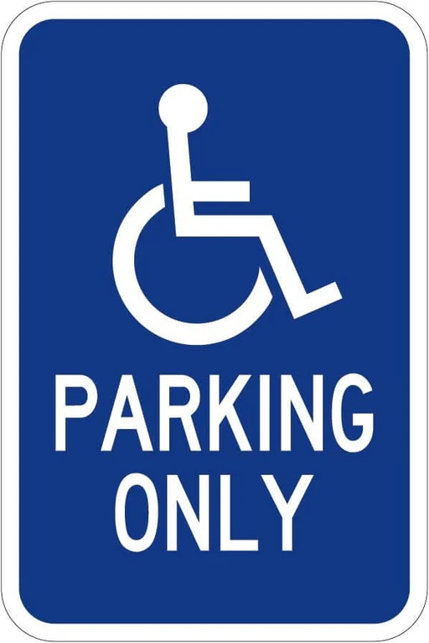

**A.** This sign indicates that all vehicles can park there at no cost.

**B.** This sign indicates that all guests can park there if no other spaces are available.

**C.** This sign indicates that this parking spot is only reserved for guests with disabilities.

**D.** This sign indicates that this parking spot is available for vehicles making deliveries.

**30.** What does the notice say?



**A.**  Drinking is only allowed in private places for those under 21.

**B.** It is illegal to sell alcohol to anyone under 21 years of age.

**C.** Anyone under 21 can drink alcohol if their parents give them permission.

**D.** Legally, people are not allowed to drink alcohol without limits after they turn 21.

***Read the following passage and mark the letter A, B, C or D on your answer sheet to indicate the correct answer to each of the following questions from 31 to 36.***

Dear Sir / Madam,

I would like to apply for the job of tour leader for your Overland Africa tours. I have had lots of useful experience for this **role**.

I have spent five months backpacking around Africa. In 2018, I visited Ethiopia, Kenya and Tanzania. I used local transport and organized my own accommodation, food and visas. I enjoyed meeting local people, learning about local traditions and visiting natural parks. I read and learned a lot about the culture and wildlife, and I even learned some Swahili and Afrikaans. This trip taught me to be independent and to organize travel arrangements.

I have completed the Active Youth Challenge. I did this while I was at high school in 2016. To complete this challenge, I firstly had to volunteer with a local organization. I helped at a social club for the elderly, where I chatted and played games with the members. The experience taught me to be patient and friendly. Secondly, I had to learn something by myself. I learned car mechanics. This taught me some useful, practical skills. Thirdly, I organized a four-day camping and hiking trip in the Scottish mountains with other students from my school. This experience taught me about camping equipment and how to **deal with** problems like bad weather and getting lost.

I believe I have lots of useful experience working as an Overland Tour Guide. I would love the opportunity to tell you more about my skills at an interview.

Yours faithfully,

Nicholas Rigby

**31.** What is the main idea of the reading passage?

**A.** A backpacking trip through Africa can expose Nicholas to new cultures.

**B.** Nicholas is sharing the story of how he became skilled at fixing cars.

**C.** One of Nicholas's experiences includes volunteering at Active Youth.

**D.** Nicholas tries to get the tour-guide job by highlighting his past experiences.

**32.** The word **role** in paragraph 1 is CLOSEST in meaning to ____________.

**A.** location **B.** feature **C.** position **D.** structure

**33.** According to the passage, what did Nicholas do in his overland trip in Africa?

**A.** He worked as a tour guide, leading groups of tourists through Africa.

**B.** He traveled by local transport and arranged his own stay and meals.

**C.** He helped people by translating English into Swahili and Afrikaans.

**D.** He paid for the whole trip to visit many natural parks in Africa.

**34.** Which country is NOT mentioned as a place Nicholas Rigby visited during his backpacking trip in Africa?

**A.** Tanzania **B.** Uganda **C.** Ethiopia **D.** Kenya

**35.** Which skill did Nicholas learn as part of the Active Youth Challenge?

**A.** He learned how to organize social clubs for the elderly in his community.

**B.** He became familiar with the local customs and traditions.

**C.** He learned how to navigate the Scottish mountains through a compass.

**D.** He became good at fixing cars by learning mechanic skills.

**36.** The word “**deal with”** in paragraph 3 is OPPOSITE in meaning to ____________.

**A.** bother **B.** handle **C.** assist **D.** ignore

***Four phrases/ sentences have been removed from the text below. For each question, mark the letter A, B, C or D on your answer sheet to indicate the correct option that best fits each of the numbered blanks from 37 to 40.***

Students now have eight periods of study a day.(37) ______. When they return home, they don’t have the energy to do homework or review knowledge or prepare for the following day.

Students now study more and more, but how much do they retain? (38) ______. At their age, students should also have time to hang out with each other and enjoy their childhood. The students’ allocated time in class should be divided (39) ______ , not just for new information.

We are forcing the students to cram too much, which will backfire. Education programs should motivate the students to continue learning by themselves, (40) ______.

**A.** into learning new knowledge and revision

**B.** rather than making them sick of learning altogether

**C.** Sometimes, they also take up to six different subjects.

**D.** Studying more doesn’t mean that students will automatically get better.

**37.** ______

**38.** ______

**39.** ______

**40.** ______